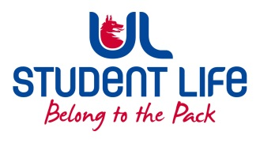
UL Student Council 2021 / 22
Meeting 4

Agenda
 | Meeting | : | UL Student Life Council
 | Date | : | November 9th 2021 (Semester 1 - Week 10)
 | Venue | : | Zoom
 | Time | : | 6pm
Members: Cillian O’ Donohue, Alice Hynes, Jordan Cassells, Seán Ó’ Maoilchiaráin, Rania Shadeed; Louis Pemble; Cían Ó’ Caoinleáin; Vishal Manuhar; Alan Enright; Deepak Venkatasuresh; Vivin Viswanath; Darren Heffernan; Karan Gupta; Denver Joseph Saldanha; Emily Timmins; Edel Straum; Ben Fitzgerald Kiely;
Izzabella Parkinson; Joe Drennan; Jeremy Pili; Mary O’ Donnell; Eoghan O’ Mahony

In Attendance: Gillian O’ Gorman; Siobhán Wilmott; John McDermott.

Apologies:

No. | Items |  |  |  | Responsible | Time Allocation
 | Welcome to New Members |  |  |  | Cían
1. | Minutes and Matters Arising  Minutes of Council Meeting – 26th October |  |  |  | Cían | 5 Mins
2. | Meeting Business
a. | Executive Reports |  |  |  | Exec | 15 mins
b. | Leadership Training |  |  |  | Cían
c
d.
e.
f.
g.
Duration: minutes Next Meeting: 23rd November 2021

