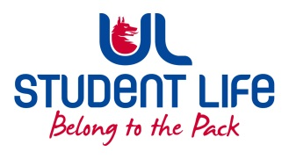
UL Student Council 2021 / 22
Meeting 3

Agenda
 | Meeting | : | UL Student Life Council
 | Date | : | October 26th 2021 (Semester 1 - Week 8)
 | Venue | : | Zoom
 | Time | : | 6pm
Members: Cillian O’ Donohue, Alice Hynes, Jordan Cassells, Seán Ó’ Maoilchiaráin, Rania Shadeed; Louis Pemble; Cían Ó’ Caoinleáin; Vishal Manuhar; Alan Enright; Deepak Venkatasuresh; Vivin Viswanath; Darren Heffernan; Karan Gupta; Denver Joseph Saldanha; Emily Timmins; Edel Straum; Ben Fitzgerald Kiely;
Izzabella Parkinson; Joe Drennan; Jeremy Pili; Mary O’ Donnell; Eoghan O’ Mahony

In Attendance: Gillian O’ Gorman; Siobhán Wilmott; John McDermott.

Apologies:

No. | Items |  |  |  | Responsible | Time Allocation
 | Welcome to New Members |  |  |  | Edel
1. | Minutes and Matters Arising  Minutes of Council Meeting – 12th October |  |  |  | Edel | 5 Mins
2. | Meeting Business
a. | Executive Reports |  |  |  | Exec | 15 mins
b. | Student Forum Format |  |  |  | Seán | 10 mins
c | Exec Report Delivery Feedback |  |  |  | ALL | 20 mins
d. | Student Forum Topics (discussion) |  |  |  | Seán | 20 mins
e. | Use of outdated pre-recorded Lectures |  |  |  | Eoghan | 5 mins
f. | Lack of Bins on Campus |  |  |  | Eoghan | 5 mins
g. | Lights on campus from ERB to PESS |  |  |  | Eoghan | 5 mins
 | AOB
Duration: 85 minutes Next Meeting: 9th November 2021

