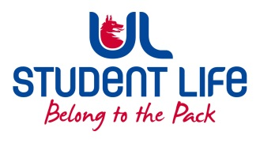
UL Student Council 2021 / 22
Meeting 2

Agenda
 | Meeting | : | UL Student Life Council
 | Date | : | October 12th 2021 (Semester 1 - Week 6)
 | Venue | : | Zoom
 | Time | : | 6pm
Members: Cillian O’ Donohue, Alice Hynes, Jordan Cassells, Seán Ó’ Maoilchiaráin, Rania Shadeed; Louis Pemble; Cían Ó’ Caoinleáin; Vishal Manuhar; Alan Enright; Deepak Venkatasuresh; Vivin Viswanath; Darren Heffernan; Karan Gupta; Denver Joseph Saldanha; Emily Timmins; Edel Straum; Ben Fitzgerald Kiely;
Izzabella Parkinson; Joe Drennan; Jeremy Pili; Mary O’ Donnell

In Attendance: Gillian O’ Gorman; Siobhán Wilmott; John McDermott.

Apologies:

No. | Items |  |  |  | Responsible | Time Allocation
1. | Minutes and Matters Arising  Minutes of Council Meeting – 28th September |  |  |  | Cían | 5 Mins
2. | Meeting Business
a. | Executive Reports |  |  |  | Exec | 15 mins
b. | Rep Recruitment Brainstorming  - 2 breakout rooms, Department Reps & Interest group reps |  |  |  | Siobhán | 8 mins
c | Exec Oversight Committee |  |  |  | Siobhán | 10 mins
d. | Academic Advocates |  |  |  | Alice | 10 mins
e. | Student Council Leadership Training |  |  |  | Siobhán | 10 mins
f. | Class Rep Feedback |  |  |  | Alice | 10 mins
 | AOB
Duration: 70 minutes Next Meeting: 26th October 2021

