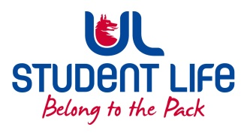
UL Student Council 2021 / 22
Meeting 1

Agenda
 | Meeting | : | UL Student Life Council
 | Date | : | September 28th 2021 (Semester 1 – Week 4)
 | Venue | : | Zoom
 | Time | : | 6pm
Members: Cillian O’ Donohue, Alice Hynes, Jordan Cassells, Seán Ó’ Maoilchiaráin, Rania Shadeed; Louis Pemble; Cían Ó’ Caoinleáin; Vishal Manuhar; Alan Enright; Deepak Venkatasuresh; Vivin Viswanath; Darren Heffernan; Karan Gupta; Denver Joseph Saldanha; Emily Timmins; Edel Straum; Ben Fitzgerald Kiely;
Izzabella Parkinson; Joe Drennan

In Attendance: Gillian O’ Gorman; Siobhán Wilmott; John McDermott.

Apologies:

No. | Items |  |  |  | Responsible | Time Allocation
1. | Minutes and Matters Arising  Minutes of Council Meeting – 13th April |  |  |  | Cían | 5 Mins
2. | Meeting Business
a. | Meeting Dates for the Year |  |  |  | Cían | 5 mins
b. | Meeting Format  ● Agenda items  ● Exec Reports  ● AOB |  |  |  | Cían & John | 5 mins
c. | PVA |  |  |  | Cían | 5 mins
d. | Introductions |  |  |  | Siobhán | 20 mins
e. | Council Bye – Law (What is Student Council & Format) |  |  |  |  | 10 mins
f. | Communication |  |  |  | John | 2 mins
g. | Training |  |  |  | Siobhán | 10 mins
h. | Executive Reports |  |  |  | Exec | 15 mins
 | AOB
Duration: 80 minutes Next Meeting: 12th October 2021

