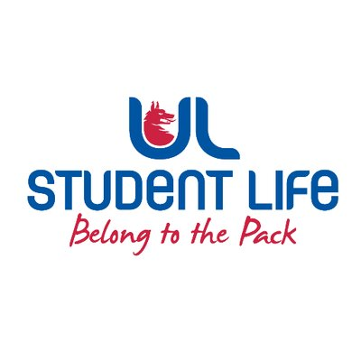
MEETING MINUTES
UL STUDENT COUNCIL 2023/24 | MEETING 2
Meeting: | UL Student Life – Student Council
Date: | October 17th (Semester 1, Week 6)
Time: | 6:00 PM
Venue: | Library Boardroom
Members: | Ronan Cahill; Ronan Mannix; Emily Rosenkranz; Katie Martin; Emma Wright; Niamh Hickey; Todor Aleksandrov; Mahir Jha; Maud Keane; Roger Dsilva; Molly McNamara; Laura Moriarty; Aine Brady; Eoghan O’Mahony; Tania Lipper; Edel Straum; Evan Mansfield; Kye Earle; Viskwaksena Balaji; Shripa Joshi; Leanne Kidney; Juliette Pinson; MD Abrabrul Haque Mohsin; Aine Brady  In Attendance: Andrew Bowie; Jasmine Ryan  Apologies: Niamh Hickey

No. | Items | Responsible | Time
 | Welcome to New Members  All the new members introduced themselves today. | Emma | 15 Mins
1. | Minutes and Matters Arising  Minutes of Council Meeting – October 3rd, 2023  Emily and Roger sit on Governing Authority. Taking part in Anti-Spiking Action.  Vegetarian Menu not Vegan Option.  Proposed Todor, seconded Eoghan. | Emma | 5 Mins
2. | Meeting Business |  | 5 mins
a. | Executive Reports  President  Attended COLC protest in Dublin and fulfilled the Student Council mandate.  80 beds delivered in Rhebogue alleviating pressure on services.  Highlighting the essential need of the Commuter Hub.  Welfare  Ran Well-Fair and Wellbeing Workshops in collaboration with SISC.  Has joined a new working group that aims to support students who are in distressing during the exam period.  Academic  He and Andrew have been investigating repeat fees. Met with the Head of Finance and there may be a review of the practice for the first time in 27 years. Hosting the “don’t drop out, drop in” space to help students considering exiting their course.  Communities  Asked for Students to bring to her attention any issues with disability access on campus. LGBTQI+ showcase for Rainbow Week featuring GOSHH and other organisations. World Pronoun Day Upcoming. Clubs and Societies Executive is going well.  Student Council Chair  Wrapped up Recruitment Drive. Thanked the room for their involvement in the Council. Acting as one-to-one contact. The Deputy Chairperson will be elected at the next council.  Clubs Officer  Met with PESS regarding damage in the hall. Met with another Clubs rep to support any Clubs lacking in capacity. Clubs and Societies group chat amalgamated into one.  Societies Officer  Working with Lauren on the amalgamation of group chats which has been beneficial to spread the word about upcoming events and campaigns within Clubs and Societies.  Experience Chair  Organising tonight’s social event. Started work on the Commuter Club.  Equality and Diversity Chairperson  Working with the Mature Student Office and SISC. Assisted in the Commuter Hub and the Sensory Hour.  Events Chairperson  Documented and reported issues with the Living Bridge lights. This matter is currently being addressed.  PSU President  Hosted the Emerge Coffee Morning and the Breakfast with Brains initiative. Also visited the new student area in Rhebogue and received feedback on accommodation. | All | 15 Mins
b. | Motion – Remote Members  The floor moved to the discussion of the Remote Members' motion.  Eoghan discussed the context of his motion for new members. Emma provided a small history of the amendment for new members.  Motion has passed. | Eoghan | 10 Mins
c. | Ratification of Meeting & Election Dates  Further discussion of Election Dates for next week. Changing the voting window. | Jasmine | 10 Mins
d. | Moving Charity Week to Week 5  Discussion of Charity Week Dates.  Maud suggested that ULSL work ahead of town RAG week and have information around. | Ronan C | 5 Mins
e. | Charities for Charity Week  Emma has made a list of top 10 charities. The Student Council will vote on their top 10 charities. There will be two local and two national charities.  The vote will be completed today. Milford Hospice and Limerick Suicide Watch; GOSHH and Doras Luminigh.  Proposed and passed. | Ronan M | 10 Mins
f. | Election of Deputy Chair
3. | AOB  Incentives – Where are Gender Neutral Bathrooms. Facilities. Where to share information. Taken as an action with Comms. | Emma | 5 Mins

Duration: 90 Mins | Next Meeting: October 31st at 6 PM

Action:

Comms on Gender Neutral

