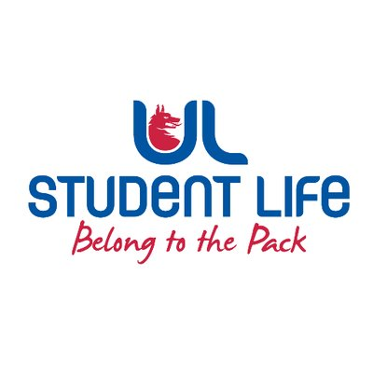
MEETING AGENDA
UL STUDENT COUNCIL 2023/24 | MEETING 12
Meeting: | UL Student Life – Student Council
Date: | November 28th 2023 (Semester 1, Week 12)
Time: | 6:00 PM
Venue: | Library Boardroom
Members: | Ronan Cahill; Ronan Mannix; Emily Rosenkranz; Katie Martin; Roger Dsilva; Emma Wright; Niamh Hickey; Maud Keane; Todor Aleksandrov; Mahir Jha; Molly McNamara; Lauren Moriarty; Viskwasena Balaji; David Lin; Evan Mansfield; Aine Brady; Shripa Joshi; Edel Straum; Eoghan O’Mahony; Juliette Pinson; Satyam Yadav, Kye Earle; Tania Lipper; MD Abrarul Haque Mohsin; Clíodhna Roche; Rhea Edison Alcanther; Prassanna Presath Barani Prasad; Scott O’Brien; Jack Trehy; Amna Basheer; Elliot Buckley; Sara Lee; Kushagra Gupta; Bjorn Vila; Kritney Phartiyal; Leanne Kidney; Patrick Curtin; Dorothy Madden; Alexander De Barra; Kieran Spaight  In Attendance: Jasmine Ryan; Dáire Martin ; Andrew Bowie  Apologies: Molly McNamara  Absent :

No. | Items | Responsible | Time
 | Welcome to New Members  Dorothy Madden – Mature Student Rep  Alexander DeBarra – CoOp Councillor  Kieran Spaight – Campus Facilities Councillor | Emma | 5 Mins
1. | Minutes and Matters Arising  Minutes of Council Meeting – November 14th, 2023 | Emma | 5 Mins
2. | Meeting Business |  | 5 mins
a. | Executive Reports | Emma | 15 mins
b. | Procedural Motion 17.8 | Emma | 10 mins
c. | Mock Trial | Emma | 5 mins
d. | Exec Oversight Committee | Jasmine | 5 mins
e. | ERB Regulations | Niamh | 10 mins
f. | Palestine Motion | Aron | 10 mins
g. | Harm Reduction | Eoghan | 5 mins
h. | Student Council Feedback | Daire | 5 mins
i. | Support for Students Affected by Conflict | Eoghan | 5 mins
j. | The Role of the LRO | LRO | 5 mins
k. | Disability Supports | Katie | 5 mins
3. | AOB | Emma | 5 mins

Duration: 90 Mins | Next Meeting: TBA

