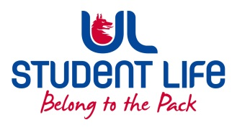
UL Student Council

Agenda
 | Meeting | : | UL Student Life Student Council
 | Date | : | 11th October 22
 | Venue | : | Library Boardroom
 | Time | : | 6pm
Members: Maeve Rutledge; Maeve Gilmore; Kieran Guiry; Laura Corcoran; Louis Pemble; Eoghan O’ Mahony; Niamh Hickey; Aldrin Sam William; Ahmed Mirza; Amanda Moloney; Evan Mansfield; Ciara O Flynn; Ella Fay; Katie Martin; Ronan Cahill; Gareth Moore, Louis Storan; Drishiti Singhal; Kaustubh Katti; Edel Straum; Emma Wright, Amy Mc Guinness; Mohit Sadarangani

In Attendance: Siobhán Wilmott; Gillian O Gorman

Apologies:

No. | Items |  |  |  | Responsible | Time Allocation
 | Welcome new members to Student Council |  |  |  | Eoghan | 5 Mins
1. | Minutes and Matters Arising
a | Minutes from 27th October 2022 |  |  |  | Eoghan | 2 Mins
b. | Matters arising
2. | Meeting Business
a. | Exec Reports |  |  |  | All Exec | 20 Mins
b. | Accommodation Survey Update & Qs |  |  |  | Laura | 10 Mins
c. | Minister Harris Meeting Update & Qs |  |  |  | Maeve R | 10 Mins
d. | Leaders for Life Launch |  |  |  | Gillian | 5 Mins
e. | Student Council Meetings |  |  |  | All | 10 Mins
f. | Student Forum Topics |  |  |  | Maeve R | 10 Mins
g. | Deputy Chair Election |  |  |  | Eoghan | 5 Mins
 | AOB |  |  |  |  | 5 Mins

Duration: 80 minutes

Next Meeting: 25th October 2022

