University of Limerick Students’ Union
Bye Law 8: Elections

- Purpose

This bye law outlines how the Students’ Union conducts all Referenda and Elections.

- Types of Elections

- Student Officer Elections
- Executive Officer Elections
- Student Council Elections
- Class Representative Elections
- Referendum

Any student who is a registered student of the University of Limerick can run for election.

The Leadership and Representation Office (LRO) facilitates and coordinates any referendums and the elections for all representative roles. The procedures for each election can vary and are outlined below.

- Returning Officer

A Returning Officer is someone who is appointed to oversee the election process. The Returning Officer, who shall not be a student, shall be appointed annually by Student Executive. The Returning Officer shall have duties and responsibilities as set out in this Bye Law. The Returning Officer may appoint a deputy and assistants to support them in their duties.

The Returning Officer shall: -

Oversee the close of nominations for Executive Elections

Oversee the count and give confirmation to the Student Representation Coordinator to announce the results of the elections Electoral and Referenda Board

- Electoral and Referenda Board

There shall be an Electoral and Referenda Board, referred to as the ERB.

The ERB shall: -

Make the rules and amend the rules from time to time (appendix)

Ensure co-ordination of all aspects of the elections or Referendum according to this constitution and the rules

The Student Representation Coordinator shall on behalf of the ERB be responsible for the implementation of the matters set out in 3.2 above.

Membership of the ERB shall be opened to all members of council. Whilst we endeavour to have representation from all student areas i.e. Council, Clubs and Societies and the PSU, we understand that this may not be possible and therefore, we will open the positions to those who are interested in joining the ERB.

Full-time Student Officers (both at ULSL and PSU) must remain neutral and therefore must abstain from ERB

No member of the ERB may be seeking or be involved in the election or Referendum for which it has been established. The ERB shall, from its number, select a chairperson. The Student Representation Coordinator shall have participant status on the ERB and will guide and coordinate the process.

The ERB shall be in place before each election and shall implement the rules for the Academic Year in accordance to the rules and guidelines in Appendix One of this Bye Law.

Where an election is in progress under this Constitution, the ERB may, at its discretion, make such directions or decisions as it may determine appropriate to govern the canvassing or other activities of candidates or their agents in seeking election.

The ERB can run a campaign to promote voting on the day and the existence of the election in general.

Campaigning Rules and Regulations are outlined in the ERB rules and guidelines in Appendix One of this Bye Law.

What to do when a referendum is called for?

Motion: The Student Council shall be responsible for approving the terms of Referenda motions on the recommendation of the Executive.

A referendum on any issue may be called at the request of any of the following: Students’ Union Executive through Student Council, 200 Students’ signatures

Validity: For the result of a Referendum to be valid, a valid vote must have been cast by at least 15 per cent of students except in the case of referenda.

The proposer of a referendum shall set out the wording of the motion, send it to the Student Representation Coordinator, who will ensure that it is discussed at both Exec and Student Council. The motion may be amended by a decision of Student Council so long as the original spirit and intention of the motion is not altered and there is agreement by the proposer.

The motion which includes the proposed amendments must be presented to the Student Council where it must receive the support general majority.

Following acceptance of the petition by the Student Council, ​the Chairperson shall seek legal advice to consider implications of the proposed amendment and report back within a period set by the Council.

The Council, having considered the legal advice, shall decide what the proposed amendments shall be progressed to referendum by way of a vote, where it must receive the support of 50% plus one of the total membership of the Council.

Motions to be sent to the Student Representation Coordinator, who will ensure it is reviewed and discussed at both Exec and Council meetings

Referendum Arrangements: -

At least 10 University Days’ notice of a Referendum shall be given on the Union website.

A Referendum shall be held not more than 20 University Days after notice has been given.

The Union shall advertise the upcoming Referendum in such manner determined by the ERB.

Referenda shall be restricted to one per topic per Academic Year.
- When should elections happen?

Executive Officers elections, which include the full-time Student Officer elections, shall be in the second semester

Nomination dates and nomination periods for following Exec posts will be set annually, by the LRO and agreed at Student Council
- Student President
- Vice President/Academic Officer
- Deputy President/Welfare Officer
- Student Communities Officer
- Student Council Chairperson
- UL Experience Chairperson
- UL Student Events Chairperson
- Equality & Diversity Chairperson
- Faculty Officer

Additional members of Exec are elected from external committees. These are, the Postgraduate President/Postgraduate Nominee, the Clubs Officer and Societies Officer

The 6 Exec positons that sit on the Board of Directors, as referenced in the Bye Law Board of Directors, will remain in office for 12 months and therefore will be called upon outside term time.

All other Exec members will start their term in Wk1 semester 1 and end their term at the end of semester 2. At times there may be cause to request Exec to work outside these times to receive training and support.

Reopen nominations (RON) shall be a candidate in full-time student officer elections.

Student Council elections shall be in the second Semester

The members of the Student Council shall be: -
Department Representatives
Interest Group Councillors
Chair of Student Council

- A Department Representative is an elected representative from a University Department within a Faculty.

- An Interest Group Councillor is an elected representative for the following positions:

The Sports Councillor, Activities Councillor and Entertainments Councillor under the remit of the Events Chairperson (executive officer)

The Equal Opportunities Councillor, Mature Student Councillor, Disabilities Councillor, LGBTQI Councillor, Home International Councillor and Visiting International Councillor, Sanctuary Rep and Parent Rep under the remit of the Equality & Diversity Chairperson (executive officer)

The Volunteering Councillor, Professional Placement Councillor, Campus Facilities Councillor, Student Services Councillor, Community Councillor, Experience Councillor and Cooperative Education Councillor under the remit of the UL Experience Chairperson (executive officer)

Any student registered for a course in a University Department is eligible to be nominated for that particular Department Representative position.

All students are eligible to be nominated for any of the Interest Group Councillor positions.

The elections of Council members and student officer positions on the Executive, will open in the second Semester, alongside the Exec elections. There will be an additional recruitment drive to fill vacant posts, from wk. 1 to wk. 4 of semester 1. The nomination periods are set by the LRO who manage all elections.

Class Representative Elections shall be held in Semester 1

For the Class Representatives elections, there shall be a recruitment drive from wk. 1 to wk. 4 of semester 1, after which elections will continue on a rolling basis with a close of nominations every week as outlined in Bye Law Representative.

The elections shall take place on the UL Student Life website, where all information on the role and election process can be found. There are 3 simple steps to the class rep nomination process:

Step 1: The student can nominate themselves by completing an online nomination form below.
Step 2: The student emails a minimum of 10 classmates asking them for their vote.
Step 3: Once 10 digital signatures are received, the LRO will be in contact to confirm if the student has been elected

- Nominations and campaigning
Nomination packs for all positions will be available from the LRO and shall be posted on the UL Student Life website. All Exec and Council must receive 20 student signatures to process nominations and Class Reps must receive 10 student signatures (as outlined above).

Digital Nominations forms for Student Council, Exec and Student Officer roles, are shared by the LRO with full details on how to complete. The nomination packs for all positions shall contain the rules, the constitution, the nomination form, a copy of the job descriptions for each position and any additional information the LRO deem necessary to support the candidate.

The completed official nomination forms shall contain, as well as the required number of proposers and seconders signatures and corresponding student ID numbers, the candidate's name as registered with the University, ID number, Course, contact details, and, in the case of directly elected members of the Executive, the name of the candidate's campaign manager. Persons standing for election to the Executive shall be required to have a campaign manager.

A student shall not propose more than one candidate to the same position for a given election. A nominated candidate shall not nominate anyone to the same position for which he/she is running.

Nomination forms must reach the Student Representation Coordinator or such other person nominated by the ERB at an agreed time on the day of close of nominations. This time will be set annually by the Student Representation Coordinator and agreed by Student Council. The nomination period and election date are scheduled by the LRO and agreed at Student Council in semester 1.

Upon signing the nomination form candidates formally agree to uphold the Constitution.

Publicity about an upcoming election
The LRO shall ensure a copy of the current election timetable, a copy of the constitution, the rules and job descriptions shall be posted on the Union website.

The Student Representation Coordinator or such other person nominated by the ERB shall publish a list of candidates (together with the proposers and seconders) which shall be displayed on the Union website within 48 hours of the close of nominations.

Candidate’s Electoral Spending
The Union shall provide limited electoral assistance to each candidate as agreed by the Executive and LRO. It is an offence for any candidate to be in receipt of sponsorship, gifts or a benefit-in-kind from vested commercial, political or outside interests. Members of the ERB are excluded from campaigning for any candidate for any election or campaigning in respect of any particular agenda concerning any Referenda motion.

The Public Debate or ‘Hustings’
The public debates with or between candidates or interested parties in an election or referendum held by the Union shall be called ‘Hustings’ and shall be convened by the ERB and the Student Representation Coordinator, who will appoint a suitable chair to facilitate the debate.

Arrangements for the Hustings set down by the Student Representation Coordinator and the ERB. This event can take place online or in person, and that decision will be taken by the Student Representation Coordinator and ERB. The below standing orders will be followed for the Hustings:

Standing Orders – Hustings
- The candidates for each position shall hust in the order of the count (in descending order of authority bottom up and alphabetical).

- Candidates shall have equal time for their main speech and no more than a third of that time for summing up.

- Order of speeches shall be alphabetical save for the summing up which will be in reverse order.

- Questions from the floor must be addressed to all candidates for a particular position.

- Candidates shall answer questions alternately, with a different candidate having to answer first each time.

- If a candidate is unable or unwilling to answer a question that question shall pass to the next candidate.

- Points of information shall be suspended for the speeches

- Parliamentary language shall be observed throughout the Hustings.

Complaints during the Campaign and Elections
Any challenge or complaint concerning the administration or good conduct of any election or referenda will be determined by the ERB within 48 hours of such a complaint being lodged in writing, print or email, to the Student Representation Coordinator on behalf of the chairperson of the Electoral and Referendum Board by any Member or the candidate or any candidate’s nominee. The Student Representation Coordinator will ensure the complaint is dealt with in a timely manner, and may need to call a committee meeting to review.

All complaint correspondence must be addressed to the chairperson of the Electoral and Referendum Board. The ERB shall regulate its own procedures and manner of determining any matter. Fair procedures shall apply and any relevant member shall have the right on request to be heard and to representation.

The ERB shall have the power of their own initiative or upon the receipt of any challenge or complaint to investigate and / or determine any matter concerning the administration or good conduct of any election or referenda.

The ERB shall have the power to discipline or disqualify any student standing for election (notwithstanding whether there is any challenge or compliant made) who: -

- Breaches any provision of this Bye Law, rules or such other decision, direction or determination made by the ERB pursuant to the provisions of this constitution
- Obstructs members of the ERB in furtherance of their duties
- Disobeys an instruction from the ERB
- Obstructs a candidate or a candidate’s agent or members of a Referendum campaign in their campaigning for an election or Referendum
- Publishes defamatory material

Canvasses for endorsement from University personnel or businesses on campus
Disciplinary powers of the Electoral and Referenda Board shall be: -

- Expulsion from Hustings
- Withdrawal of Union assistance with election expenses
- Disqualification from the election

Any appeal against any decision or direction of the ERB under this constitution must be directed to and received by the Returning Officer within 48 hours of the decision or direction. Appeals must be submitted in writing to the Returning Officer. The Returning Officer shall decide the manner in which any appeal shall be determined.

Fair procedures shall apply and any relevant member shall have the right on request to be heard and to representation. The Returning Officer’s decision on the appeal shall be final and binding on all parties.

The Returning Officer may, but shall not be required, to seek legal advice. The decision of the Returning Officer must be communicated in writing to the appellant and the ERB.

- Voting Procedures
All elections and referenda shall be by a secret ballot and, the case of elections, by the system of proportional representation by single transferable vote as governed by the Oireachtas for Dáil elections.

The Union shall run electronic elections, however if a paper election is required, the procedure below will be followed.

For a paper election: a voting paper will be issued to each voter, which shall bear the union stamp and votes will be cast in sealed ballot boxes. In the case of elections ballot papers shall bear the name of each candidate and the office being contested.

Polling stations in respect of a paper poll shall be situated in areas giving greatest convenience to students. Polling stations shall remain open for duration of the election.
The location of the polling stations shall be decided by the ERB and be published by the LRO in advance of polling day.

No other polling station can be opened other than those authorised by the ERB.
In any paper election, voters shall produce a University ID Card before being allowed to vote. Only a University ID Card or a letter from the University Administration confirming student status shall be accepted as authentication of a student’s ID number.

The Election and Referenda Counting and Declaring of Votes for a Paper Ballot
The counting of votes shall take place immediately after the closing of the polling stations.
The only people allowed within the designated area of the count shall be the Returning Officer, the Student Representation Coordinator, the ERB, their staff, plus in the case of elections the campaign managers for each of the declared candidates for student officer posts for that particular count.

In the case of elections, the counting procedures shall be in accordance with the procedures for elections to Dáil Éireann as governed by the Oireachtas: ascertaining total poll, valid poll, and quotas for each position.

There will be a facility for reopening nominations in the case of student officer elections.

For an electronic election: an electronic ballot (or e-ballot) will be issued to each voter. The election site shall be considered verification by the Union of the ballot paper in the absence of the Union stamp.

Votes will be cast by the voter and electronically added to the count. In the case of elections, the e-ballot should, bear the name of each candidate and the office being contested.

In the case of electronic elections, the candidate will be able to submit additional election material to the Student Representation Coordinator or such other person nominated by the ERB and, subject to approval of the material in accordance with ERB rules and guidelines, the material may be uploaded to the election website by the Student Representation Coordinator or such other person nominated by the ERB.

There will be a facility for reopening nominations in the case of student officer elections.

Electronic Polling will follow the same polling principles as a paper election, in so far as possible unless specifically provided otherwise by this Bye Law.

For the purposes of electronic voting, an electronic voting device shall be considered a polling station. All computer laboratories on campus will be considered public polling stations.

The prohibition on canvassing within a 10 metre radius of a polling station on polling day applies to public polling stations only in the case of electronic elections.

The electronic electorate will be based on the registered students in the University of Limerick database held and updated by the IT Department and Student Academic Affairs.

Only students who have registered will be in the database on the day of polling.

The official results shall be declared by the Student Representation Coordinator after each count.

In the case of elections, candidates have the right to request a recount or campaign managers have the right to request a recount on behalf of their candidate up 4pm on the following day after the result of the count has been announced.

In the case of referenda, any of the following persons shall have a right to request a recount up to 4pm on the following day after the result of the count has been announced: -

In the case of a referendum called by the student council, any member of the student council in attendance at the student council meeting that decided to call the referendum;

In the case of a referendum called by a petition of students, any student whom signed the petition.

The Returning Officer shall make the decision as to whether a recount takes place. A recount shall take place within five University days of the official results being declared for a paper ballot at the time specified by the returning officer.

A space adjacent to the designated area of the count shall be reserved for tally persons.
The Election Counting and Declaring of Votes for an Electronic Ballot
With an electronic election count there is no count and the results are immediate.
In the case of elections, candidates have the right to request a recount or campaign managers have the right to request a recount on behalf of their candidate up 4pm on the following day after the result of the count has been announced.

In the case of referenda, any of the following persons shall have a right to request a recount up to 4pm on the following day after the result of the count has been announced: -

- In the case of a referendum called by the Student Council, any member of the Student Council in attendance at the Student Council meeting that decided to call the referendum;
- In the case of a referendum called by a petition of students, any student whom signed the petition.

In the case of an electronic ballot the recount shall take place within four University days.

- Term of Office:

Once elected the members of the Student Council, Executive who don’t sit on the Board of Directors, and Class Representatives shall take office from wk. 1 semester 1 until the end of the academic year.

Student Representatives who are elected to sit on Board of Directors shall take office from end of semester 2 for a full 12 months, specific dates will be set annually by the LRO.

There shall be no prohibition on any member standing for election again for any position including the position already held by that member.

All filled positions for Student Council which include Exec and Student Officer roles, will be posted on the UL Student Life website.

Appendix One

ERB Rules and Guidelines 2021/22

It is the responsibility of each candidate and their campaign team to read the regulations in full, ensure they are adhered to and to seek clarification where required, by emailing siobhan.wilmott@ul.ie

In addition to Constitutional Requirements, the Electoral and Referenda Board has put in place by-laws and regulations for the elections. Some constitutional elements have been highlighted here as well as other regulations for the duration of these elections.

Candidates and their campaign team members must obey all instructions from the ERB. Failure to do so may result in disciplinary procedure.
In the interest of fairness, a limit of €300 will be in place for the running of each candidate’s campaign. All items purchased will require a receipt to be handed into the Representation office.

- Nomination Details

  - Candidates Name: The students’ registered name with the University of Limerick. (see end note).
  - All proposers and seconders must be registered as current students of the University of Limerick.
  - Nominations open XXX (Week X) 2022 at X.
  - Nominations close XXX (Week X) 2022 at X
  - A deposit of €50 (Fifty euro) is required to process the nomination; this will be returned on the basis of adhering to ERB Rules and Regulations.
  - The deposit is only refundable on the day immediately after polling to each candidate given that, in the opinion of the Returning Officer, the candidate has run a genuine campaign, abided by the rules and guidelines and all their election material has been disposed of correctly.
  - A nomination form is considered complete by submitting the following to the Returning Officer via siobhan.wilmott@ul.ie
  - Please ensure that you receive an email receipt.
    - Completed nomination forms
    - €50 (Fifty euro) deposit via bank transfer
    - Completed manifesto softcopy (PDF) emailed to siobhan.wilmott@ul.ie
    - A softcopy of candidate’s headshot photograph on a white background which they wish to be put on the ballot page. The candidates face must not be obscured
  - Candidates must submit their final manifesto (pdf) and headshot photograph (jpg format) via email to siobhan.wilmott@ul.ie by close of nomination X (Week X) 2022 at X.

- Campaign Meeting to outline Rules (All must attend)
A meeting of all Candidates and their Campaign Managers shall take place over zoom on the evening of XXX (Week X).
Failure to attend will result in ERB action.

- Election Details (How the election will be run)
  - The online election shall take place on XXX (Week X) X.
  - Due to online voting, all computer labs on campus will be considered polling stations and therefore subject to the Student Life Constitution governance. Campaigning of any kind is strictly prohibited within 10 meters of University computer labs.
  - If there is an internet outage on campus on election-day that is >30min, the ERB may extend the election deadline to correspond with the outage time.
  - The Returning Officer has the authority to delay declaring election results until such time as all election material has been disposed of correctly.
  - On election day the candidate or their campaign team are not allowed to hand someone a laptop, iPad, tablet, phone or any device to vote on. Voting is a private act where you cannot stand beside someone while they cast their vote.

- Campaigning Rules and Regulations
  - Campaign material must display the constitutionally prescribed “Issued by (Name of Campaign Manager), Campaign Manager for (Name of Candidate)”. Any material without the constitutionally prescribed “Issued by (Name of Campaign Manager), Campaign Manager for (Name of Candidate)” shall be immediately removed from circulation. This includes all social media forums. Campaign Cups must be marked to indicate which campaign team issued them but do not need the “Issued by (Name of Campaign Manager), Campaign Manager for (Name of Candidate)”.
  - All social media pages and posts must also follow this format in the Bio section. “All posts issued by (Name of Campaign Manager), Campaign Manager for (Name of Candidate)”
  - Normal UL and Student Life Postering Policy apply. However, posters do not need to be stamped by Student Life. Electioneering posters are therefore exempt of a Student Life stamp requirement to be placed on notice boards.
Posters that are not on an official notice board or in a prohibited area will be taken down and will count as a first strike for ERB.

UL Building and Estates Signage & Campaigning Rules
  - No signage is permitted outside entrances to University – see appendices for maps for where signs can be placed. Sign stakes must not be more than 1ft deep in the ground. Signage is permitted along main road for week of election only.
  - Signs must be removed by end of day of election, X.
  - Signage cannot obstruct line of sight of pedestrians, vehicle drivers and cyclists.
  - Signage cannot be erected on any structure, except on official notice boards. Signs are not to be erected on tree, plants shrubbery.
  - All Stickers on are strictly prohibited and not allowed in the elections.
  - Bluetack or whitetack use on walls is prohibited and may result in fines from UL Buildings and Estates.
  - Campaigning
  - At no point can candidates seek or tell people to vote for them in the election until after the meeting with the returning officer, failure to abide by this will result in disciplinary action from ERB.
  - Campaigning must not interfere with lectures
  - Campaigning must not interfere with traffic on, entering of leaving campus
  - Candidates will be responsible for any littering of the campus from leaflets disposed on the ground and erected in unofficial areas
  - Campaigning within the library building and 5m outside the library door is prohibited.
  - A softcopy of all promotional materials (posters, flyers, manifesto summaries, Facebook & website pages or any electronic material etc.) must be submitted to siobhan.wilmott@ul.ie for approval by the ERB. Candidates can appeal the returning officer’s decisions to the ERB via the Chair of the ERB.
  - The Election Material can be submitted for approval to the ERB at any point after the open of nominations up until COB on XXX – after the candidates and campaign managers meeting but no campaign material can be distributed until XXX.
  - Approved social media pages must be submitted to siobhan.wilmott@ul.ie by COB on XXX and may only be published publically on XXX. Any candidate who is in breach of this regulation shall be subject to sanction by the Returning Officer.
  - The Union electoral assistance for the 4 fulltime Student Life Student Officer positions: President; Welfare; and Academic and Communities, will be €1000 divided between all the candidates. The maximum amount that can be allocated to a candidate is €100 but will be less if there are more than 10 candidates running between all three elections. Electoral funding will only be given in arears on a vouched receipt basis. Refunds will be by electronic bank transfer only. Candidates must supply bank details via email.
  - For Student Life Exec part-time and PSU elections, there will be a maximum of €50 electoral funding assistance per person on a vouched expense only basis.
  - Campaigning or postering by campaign teams is not allowed within the Student Life Building this also includes any Student Life Facebook pages/ Social Media Sites or Information Screens. This is to allow for impartiality of the Union.
  - Campaign posters may not be installed/placed on the River Shannon islands.
  - Any untrue, defamatory election material is prohibited. If a candidate and/or their campaign team is found to have published defamatory material they must remove it immediately, publish a correction and give a genuine apology subject to ERB approval. ERB requires the correction to be published in such manner as will ensure that it is communicated to all or substantially all of those persons to whom the defamatory statement was published.
  - Candidates and their campaign team may not distribute any food items within the Red Raisins confines.
  - Any candidate/union member/lecturer/person sending email(s), as a candidate or on behalf of a candidate, to the UL Microsoft Outlook distribution list(s) will be considered in breach of the University’s Email Policy (entitled the ‘Code of Conduct for Users of the University of Limerick's Computing Resources’). No emails are to be sent by any student promoting a candidate to any student with a @studentmail.ul.ie or @ul.ie account. This includes asking people to email on your behalf. Class Reps will lose their email privileges if they email their classes endorsing any candidate.
  - It is an offence for a candidate to be in receipt of sponsorship, gifts or benefit-in-kind from vested commercial and/or political interests as well as an endorsement from a club or society.

It is an offence for a candidate to be in a receipt of an endorsement either in person or online by:
a. Any person who is not currently a registered student of the University of Limerick.
b. Any student who is not using their personal social media account.
c. Any person who does not have a vote in the student election.
c. Any other person that the ERB deem to give a candidate an unfair advantage.

All endorsements must be clear of any affiliations with clubs, societies, business, religions or any other organisation that the ERB deem to be inappropriate.

Social media influencers etc. who are current UL registered students can endorse campaigns. Any other influencer or individual with a big social media following cannot. This is to prevent unfair advantages between candidates. Businesses, social media influencers, athletes or well-known external personnel cannot endorse campaigns.

An influencer is one who exerts influence: a person who inspires or guides the actions of others; often, specifically: a person who is able to generate interest in something (such as a consumer product) by posting about it on social media.

  - Current Executive Officers not contesting an election may not campaign for any candidate and must remain impartial.
  - The Student Life logo, UL Logo or any other logos issued by Student Life or the Electoral & Referendum Board may not be included in campaign material.
  - All campaign issues and concerns should be addressed to siobhan.wilmott@ul.ie any issues on Election Day should be addressed to the designated representative from the ERB . The ERB will only deal with written or emailed formal complaints.

- Canvassing
5.1 On the election day candidates and their campaign team are allowed to engage in limited canvassing. Regardless of a physical or online poll, limited canvassing only allows for reminding students online, via their campaign page, that it is voting day and to go vote for them or who they believe is the right candidate and, to remind students to look at their material over the campaign period.
5.2 Candidates cannot physically or virtually contact/approach students individually on the day of voting asking that they vote for them.

- R.O.N Campaign
6.1 If a student wishes to run a R.O.N campaign, then in the interest of fairness they must fill out the declaration form to act as a campaign manager for R.O.N.

6.2 R.O.N Material cannot be defamatory towards other candidates. If ERB deem
It as defamatory it will consider what course of action to take against the
potential candidate.

- ERB Disciplinary Powers:
  - Election Observers will be employed by the Student Life. They will be visible on campus and in the surrounding housing estates on Election Day.
  - The Observers are responsible for monitoring all electioneering activities and they shall report on any regulation breach(s) to the Returning Officer/ Representation Office who will be entitled to take such action as may be appropriate, up to and including disqualification from the election if deemed appropriate.
  - If a candidate or a member of their team breaches Schedule 1 Election Regulations of the STUDENT LIFE Constitution; Schedule 1.45 outlines the ERB can discipline the candidate by:
    - Public Reprimand & Monetary Fines,
    - Expulsion from Hustings
    - Withdrawn the union electoral assistance
    - Disqualification from the election
    - In the event of a rule or rules been broken ERB may compel a candidate and their campaign team to take specific action. Failure of the candidate and their campaign team to take the specified action in the time allocated may result in disqualification from the election.

Appendices
Event signage zones
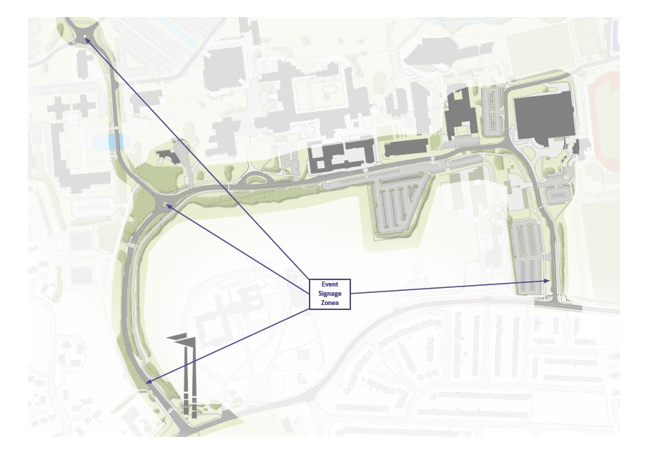

West Gate Entrance – Flag Poles
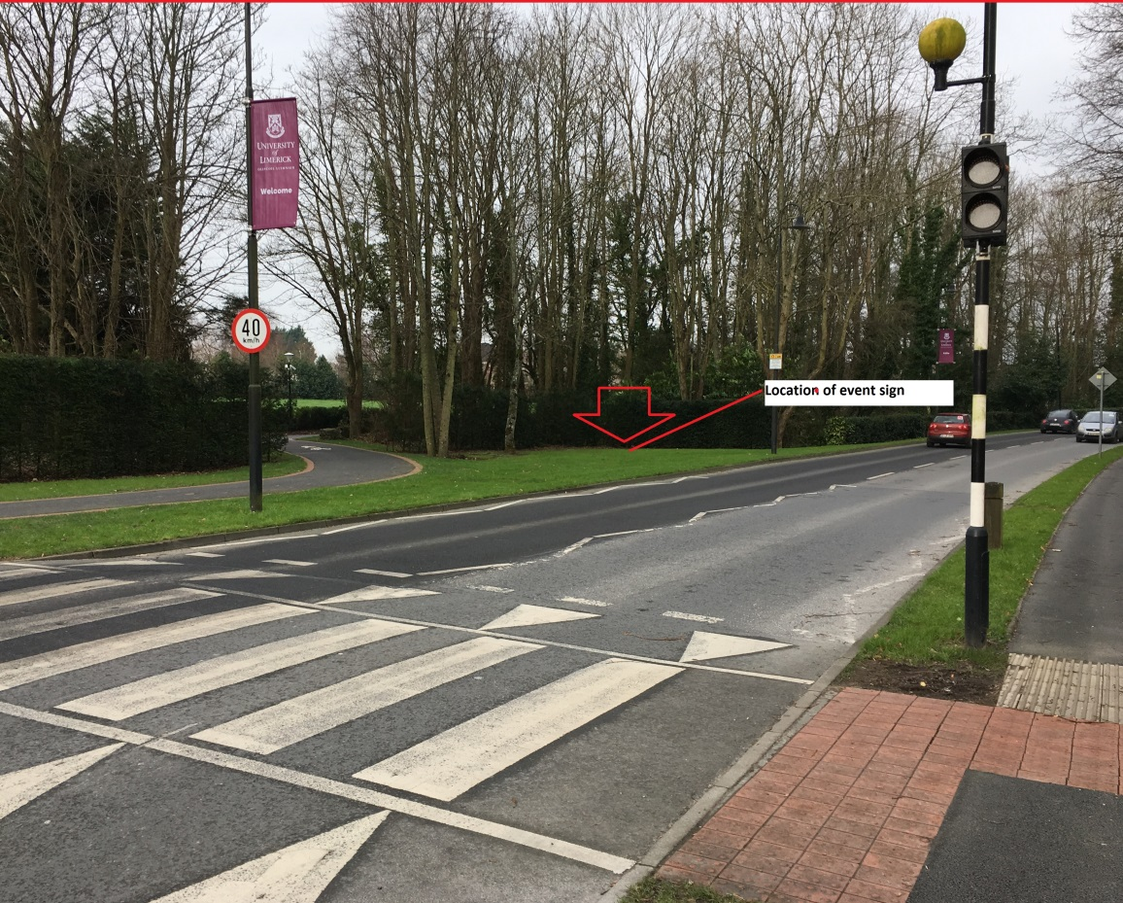

East Gate Entrance – Back Gate
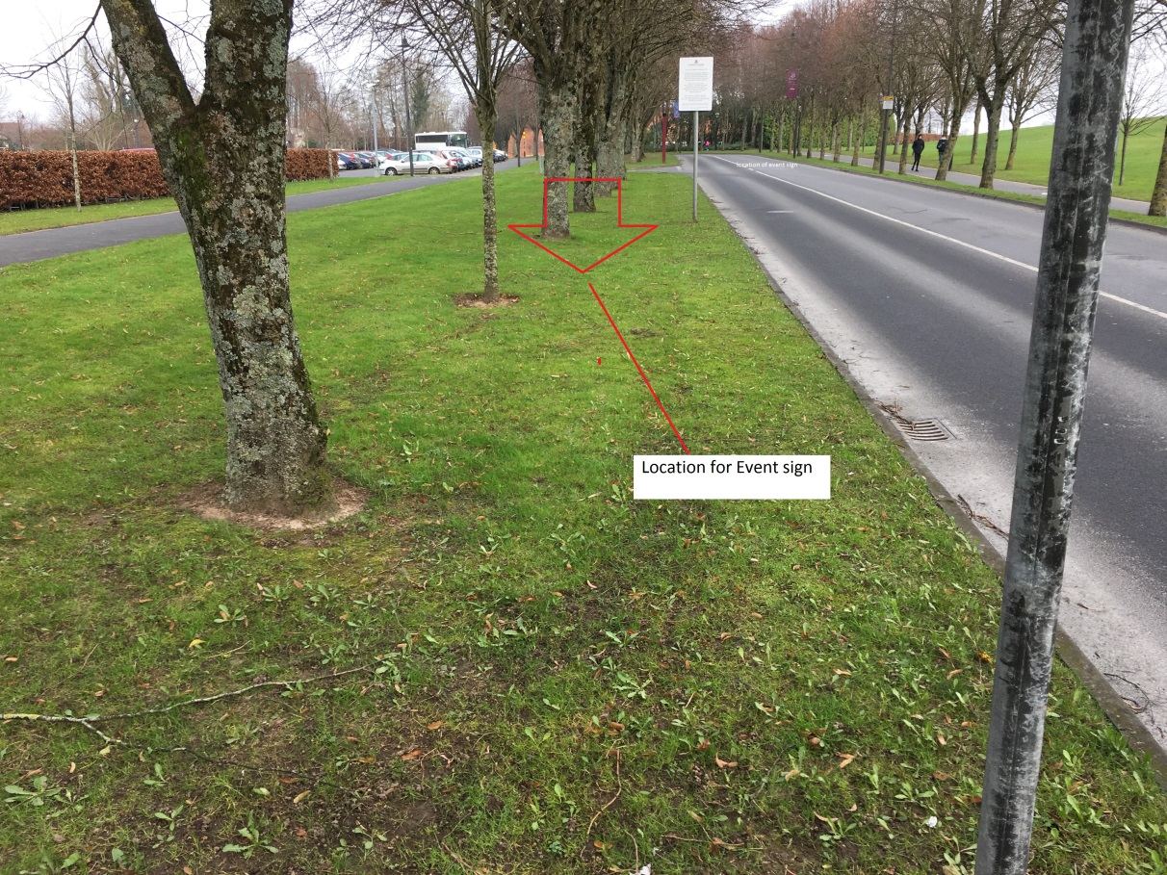

The completed official nomination forms shall contain, as well as the required number of proposers and seconders signatures and corresponding student ID numbers, the candidate's name as registered with the University, ID number, Course, contact details, and, in the case of directly elected members of the Executive, the name of the candidate's campaign manager. Persons standing for election to the Executive shall be required to have a campaign manager. Exceptions to this rule will only be permitted in the case where the candidate can provide evidence showing regular university teaching communication using a name other than their registered name. The purpose of this provision is to accommodate transgender students run for election under the name they are commonly known as. LRO will conduct a check with relevant university staff to verify the validity of the request.

