ERB RULES & GUIDELINES
elections 23/24

- Nomination Details

1.1 Candidates Name: The students’ registered name with the University of Limerick. (see end note).
1.2 All proposers and seconders must be registered as current students of the University of Limerick.
1.3 Nominations open Friday the 23rd of February 2024 at 9:00 am
1.4 Nominations close Wednesday the 6th of March 2024 at 12:00 pm.
1.5 A deposit of €50 (Fifty euro) is required to process the nomination; this will be returned on the basis of adhering to ERB Rules and Regulations.
1.6 The deposit is only refundable on the day immediately after polling to each candidate given that, in the opinion of the Returning Officer, the candidate has run a genuine campaign, abided by the rules and guidelines and all their election material has been disposed of correctly.
1.7 A nomination form is considered complete by submitting the following to the Returning Officer via daire.martin@ul.ie:
1.8 Please ensure that you receive an email receipt.
1.8.1 Completed nomination forms
1.8.2 €50 (Fifty euro) deposit via bank transfer
1.8.3 Completed manifesto softcopy (1 PDF & 1 Word Doc) emailed to daire.martin@ul.ie
1.8.4 A softcopy of candidate’s headshot photograph on a white background which they wish to be put on the ballot page. The candidates face must not be obscured
1.9 Candidates must submit their final manifesto (PDF & Word Doc) and headshot photograph (jpg format) via email to daire.martin@ul.ie by 7:00 AM Wednesday 6th of March 2024.

2. ERB Campaign Meeting to outline Rules (All must attend)

A meeting of all Candidates and their Campaign Managers shall take place Thursday, 7th of March at 1:00pm. Failure to attend will result in ERB action.

3 Election Details (How the election will be run)
3.1 The election shall take place on Thursday 14th of March from 8:00 am – 4:00 pm.
3.2 Due to online voting, all computer labs on campus will be considered polling stations and therefore subject to the Student Life Constitution governance. Campaigning of any kind is strictly prohibited within 10 meters of University computer labs. In addition to this, multiple voting stations will be opened on campus and manned by LRO, it is strictly prohibited to campaign within 10 metres of these polling stations.
3.3 If there is an internet outage on campus on election-day that is >30min, the ERB may extend the election deadline to correspond with the outage time.
3.4 The Returning Officer has the authority to delay declaring election results until such time as all election material has been disposed of correctly.
3.5 On election day the candidate or their campaign team are not allowed to hand someone a laptop, iPad, tablet, phone, or any device to vote on. Voting is a private act where you cannot stand beside someone while they cast their vote.

3. Campaigning Rules and Regulations

4.1 Campaign material must display the constitutionally prescribed “Issued by (Name of Campaign Manager), Campaign Manager for (Name of Candidate)”. Any material without the constitutionally prescribed “Issued by (Name of Campaign Manager), Campaign Manager for (Name of Candidate)” shall be immediately removed from circulation. This includes all social media forums. Campaign Cups must be marked to indicate which campaign team issued them but do not need the “Issued by (Name of Campaign Manager), Campaign Manager for (Name of Candidate)”.
4.2 All social media pages and posts must also follow this format in the Bio section. “All posts issued by (Name of Campaign Manager), Campaign Manager for (Name of Candidate)”
4.3 Normal UL and Student Life Postering Policy apply. However, posters do not need to be stamped by Student Life. Electioneering posters are therefore exempt of a Student Life stamp requirement to be placed on notice boards.

Posters that are not on an official notice board or in a prohibited area will be taken down and will count as a first strike for ERB.

4. UL Building and Estates Signage & Campaigning Rules

4.4 No signage is permitted outside entrances to University – see appendices for maps for where signs can be placed. Sign stakes must not be more than 1ft deep in the ground. Signage is permitted along main road for week of election only.
4.5 Signs must be removed by end of day of election, Thursday 14th of March.
4.6 Signage cannot obstruct line of sight of pedestrians, vehicle drivers and cyclists.
4.7 Signage cannot be erected on any structure, except on official notice boards. Signs are not to be erected on tree, plants shrubbery.
4.8 All Stickers on are strictly prohibited and not allowed in the elections.
4.9 Bluetack or whitetack use on walls is prohibited and may result in fines from UL Buildings and Estates.
4.10 Campaigning
4.11 At no point can candidates seek or tell people to vote for them in the election until after the meeting with the returning officer, failure to abide by this will result in disciplinary action from ERB.
4.12 Campaigning must not interfere with lectures
4.13 Campaigning must not interfere with traffic on, entering of leaving campus
4.14 Candidates will be responsible for any littering of the campus from leaflets disposed on the ground and erected in unofficial areas
4.15 Campaigning within the library building and 5m outside the library door is prohibited.
4.16 A softcopy of all promotional materials (posters, flyers, manifesto summaries, Facebook & website pages, or any electronic material etc.) must be submitted to daire.martin@ul.ie for approval by the ERB. Candidates can appeal the returning officer’s decisions to the ERB via the Chair of the ERB.
4.17 The Election Material can be submitted for approval to the ERB at any point after the open of nominations up until 7:00 am Monday 11th of March 2024 - after the candidates and campaign managers meeting but no campaign material can be distributed until 12:00 pm Monday 11th of March 2024.
4.18 Approved social media pages must be submitted to daire.martin@ul.ie by 7:00 AM Monday 11th of March 2024 and may only be published publicly on 12:00 pm Monday 11th of March 2024. Any candidate who is in breach of this regulation shall be subject to sanction by the Returning Officer.
4.19 The Union electoral assistance for the 4 fulltime Student Life sabbatical positions: President; Welfare; and Academic and Communities, will be €1000 divided between all the candidates. The maximum amount that can be allocated to a candidate is €100 but will be less if there are more than 10 candidates running between all three elections. Electoral funding will only be given in arears on a vouched receipt basis. Refunds will be by electronic bank transfer only. Candidates must supply bank details via email.
4.20 For Student Life Exec part-time and PSU elections, there will be a maximum of €50 electoral funding assistance per person on a vouched expense only basis.
4.21 Campaigning or postering by campaign teams is not allowed within the Student Life Building this also includes any Student Life Facebook pages/ Social Media Sites or Information Screens. This is to allow for impartiality of the Union.
4.22 Campaign posters may not be installed/placed on the River Shannon islands.
4.23 Any untrue, defamatory election material is prohibited. If a candidate and/or their campaign team is found to have published defamatory material they must remove it immediately, publish a correction and give a genuine apology subject to ERB approval. ERB requires the correction to be published in such manner as will ensure that it is communicated to all or substantially all of those persons to whom the defamatory statement was published.
4.24 Candidates and their campaign team may not distribute any food items within the Red Raisins confines.
4.25 Any candidate/union member/lecturer/person sending email(s), as a candidate or on behalf of a candidate, to the UL Microsoft Outlook distribution list(s) will be considered in breach of the University’s Email Policy (entitled the ‘Code of Conduct for Users of the University of Limerick's Computing Resources’). No emails are to be sent by any student promoting a candidate to any student with a @studentmail.ul.ie or @ul.ie account. This includes asking people to email on your behalf. Class Reps will lose their email privileges if they email their classes endorsing any candidate.
4.26 It is an offence for a candidate to be in receipt of sponsorship, gifts, or benefit-in-kind from vested commercial and/or political interests as well as an endorsement from a club or society.

It is an offence for a candidate to be in a receipt of an endorsement either in person or online by:

a. Any person who is not currently a registered student of the University of Limerick.
b. Any student who is not using their personal social media account.
c. Any person who does not have a vote in the student election.
c. Any other person that the ERB deem to give a candidate an unfair advantage.

All endorsements must be clear of any affiliations with clubs, societies, business, religions, or any other organisation that the ERB deem to be inappropriate. Social media influencers etc. who are current UL registered students can endorse campaigns. Any other influencer or individual with a big social media following cannot. This is to prevent unfair advantages between candidates. Businesses, social media influencers, athletes or well-known external personnel cannot endorse campaigns. An influencer is one who exerts influence: a person who inspires or guides the actions of others; often, specifically: a person who is able to generate interest in something (such as a consumer product) by posting about it on social media.

4.27 Current Executive Officers not contesting an election may not campaign for any candidate and must remain impartial.
4.28 The Student Life logo, UL Logo or any other logos issued by Student Life, or the Electoral & Referendum Board may not be included in campaign material.
4.29 All campaign issues and concerns should be addressed to daire.martin@ul.ie any issues on Election Day should be addressed to the designated representative from the ERB. The ERB will only deal with written or emailed formal complaints.

5. Canvassing
5.1 On the election day candidates and their campaign team are allowed to engage in limited canvassing. Regardless of a physical or online poll, limited canvassing only allows for reminding students online, via their campaign page, that it is voting day and to go vote for them or who they believe is the right candidate and, to remind students to look at their material over the campaign period.
5.2 Candidates cannot physically or virtually contact/approach students individually on the day of voting asking that they vote for them.

6. R.O.N Campaign
6.1 If a student wishes to run a R.O.N campaign, then in the interest of fairness they must fill out the declaration form to act as a campaign manager for R.O.N.
6.2 R.O.N Material cannot be defamatory towards other candidates. If ERB deem it as defamatory it will consider what course of action to take against the potential candidate.

7. ERB Disciplinary Powers
7.1 Election Observers will be employed by the Student Life. They will be visible on campus and in the surrounding housing estates on Election Day.
7.2 The Observers are responsible for monitoring all electioneering activities and they shall report on any regulation breach(s) to the Returning Officer/ Representation Office who will be entitled to take such action as may be appropriate, up to and including disqualification from the election if deemed appropriate.
7.3 If a candidate or a member of their team breaches Schedule 1 Election Regulations of the STUDENT LIFE Constitution; Schedule 1.45 outlines the ERB can discipline the candidate by:
7.3.1 Public Reprimand & Monetary Fines,
7.3.2 Expulsion from Hustings
7.3.3 Withdrawn the union electoral assistance
7.3.4 Disqualification from the election
7.3.5 In the event of a rule or rules been broken ERB may compel a candidate and their campaign team to take specific action. Failure of the candidate and their campaign team to take the specified action in the time allocated may result in disqualification from the election.

APPENDICES
Event signage zones
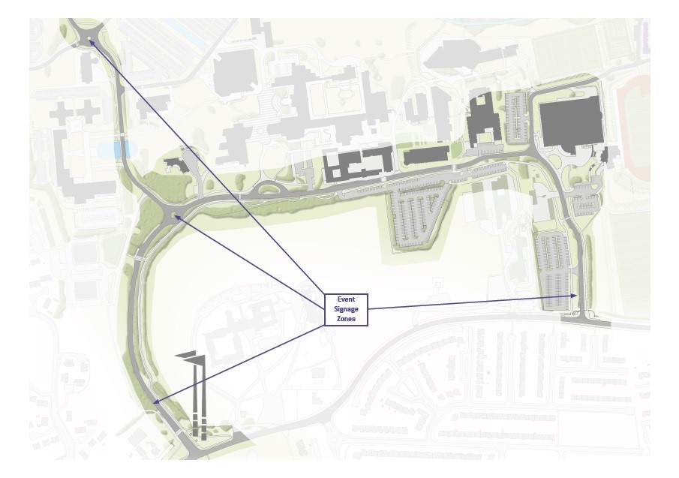
West Gate Entrance – Flag Poles
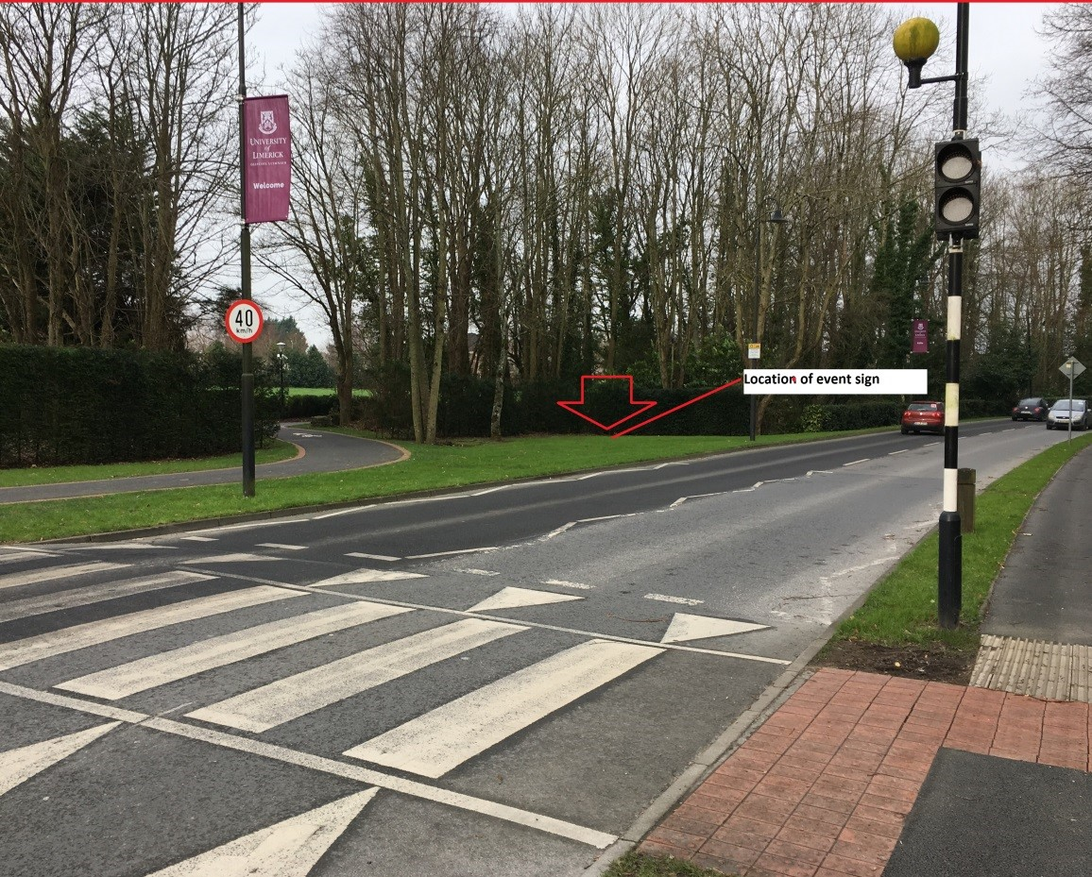

East Gate Entrance – Back Gate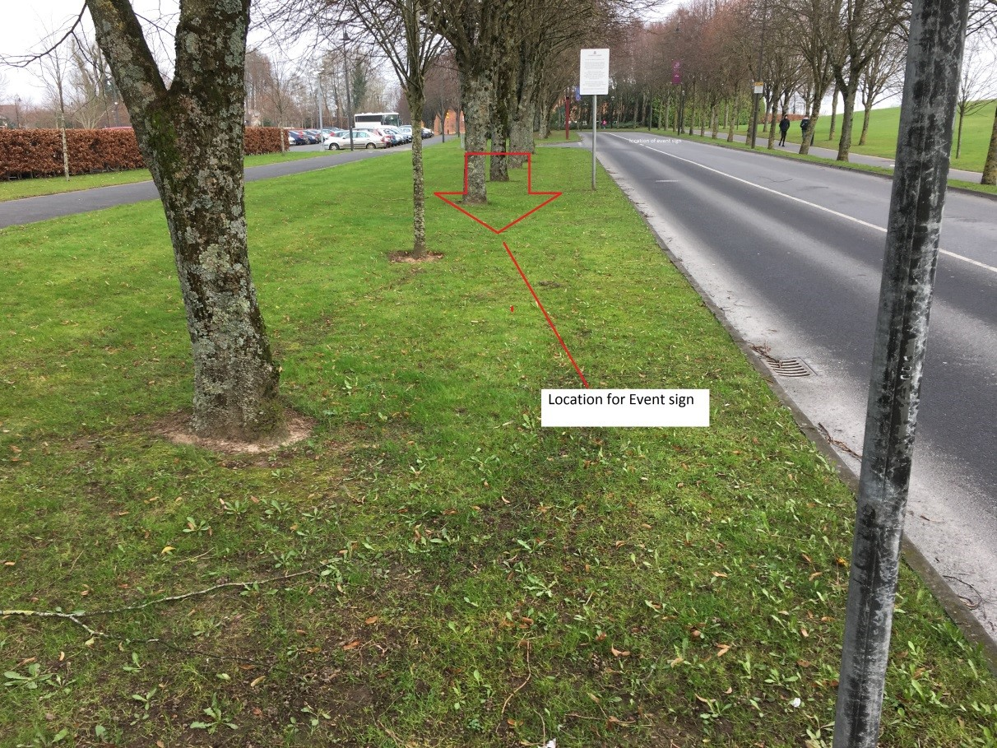

¹The completed official nomination forms shall contain, as well as the required number of proposers and seconders signatures and corresponding student ID numbers, the candidate's name as registered with the University, ID number, Course, contact details, and, in the case of directly elected members of the Executive, the name of the candidate's campaign manager.

Exceptions to this rule will only be permitted in the case where the candidate can provide evidence showing regular university teaching communication using a name other than their registered name.

LRO will conduct a check with relevant university staff to verify the validity of the request.

Persons standing for election to the Executive shall be required to have a campaign manager. Both are required to uphold and sign the Candidate and Campaign Manager Declaration Form.

